Assignment 14 (January 9 – January 21)

1. Determine whether the following functions are homogenous. If so, of what degree?
a) 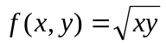
b) 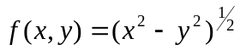
c) 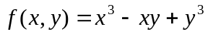
d) 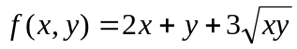
e) 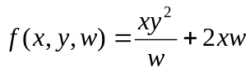
f) 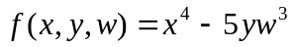

2. Deduce from Euler’s theorem that, for production function with constant returns to scale:
When MPP_{k} = 0, APP_{L} is equal to MPP_{L .}
When MPP_{L} = 0, APP_{K} is equal to MPP_{K}

3. Let the production function 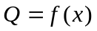 of a firm be a differentiable homogenous function of degree 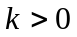. The firm wants to maximize its revenue 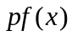 subject to 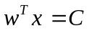, where 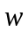 is a vector of input prices,  is the output price,  - the total cost of production. Assume that the firm buys all of the factors in positive quantities. Show that the cost function is a homogenous function 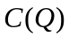 of degree 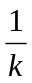. Hint: use Euler’s equation and derive necessary conditions for the minimization problem.

4. Find the general solution and the definite solution, given:
(a) 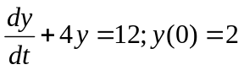 (b) 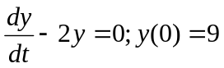
(c) 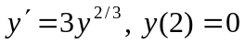 (d) 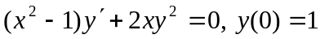

5. Solve the following first-order linear differential equation:
